Routine Specifications
- Note: Please remember to use a mask when changing specific bits in a register!

- __main
  - Configure all inputs and outputs (reference each lab we did for configuring push-pull/open-drain and things like that), initialize register values (0x0 for R4-R7, 0x00000900 for R8, and 0x00000008 for R9), then write a “begin” label after all the configurations & initializations are done
  - Write a “1” (on) to the “system idle” bit in R8
  - Branch with link to update_LED_states
  - Display “Press ‘#’ to Start” message on Tera Term.
  - Scan for a “#” input on the keypad
    - When “#” has been pressed:
      - Write a “0” (off) to the “system idle” bit in R8
      - Branch with link to update_LED_states
      - Prompt the user to press “0” if exiting the garage or “1” if entering the garage
    - If “1” is selected:
      - Prompt the user to press “*” for manual operation, “#” for automatic operation, or “9” for priority parking
      - If “*” is pressed, branch to manual_sequence
      - If instead “#” is pressed, branch to automatic_sequence
      - If instead “9” is pressed, branch to priority_sequence
    - If instead “0” is selected:
      - Branch to exit_sequence
  - Branch back to the “begin” label
- exit_sequence
  - Prompt the user to input 1, 2, 3, or 4 (reserved level) from the keypad to move the platform to that level
  - Scan for input 1, 2, 3, or 4 on the keypad, and store the selection in a register R0-R3
  - Check whether the selected parking level is empty by referring to the parking spots tracking in R8
    - If the level is empty, display “level is empty” and branch back to the “begin” label in __main
    - Otherwise, continue
  - Update R5 with the motor position of the selected level (4096, 8192, 12288, or 16384, in steps) by referring to register R0-R3
  - Branch with link to move_platform
  - Prompt the user to input “#” when the car has entered the platform, and keep checking whether they enter a “#” until the key has been pressed
    - Update R8 to indicate that a car is on the platform
  - Branch with link to increment_open_spots
  - Update R8 with the new number of cars at the selected level
  - Update R5 with the motor position of the ground level (0, in units of steps)
  - Branch with link to move_platform
  - Branch with link to open_gate
  - Prompt the user to input “#” when they have exited the platform, and keep checking whether they enter a “#” until the key has been pressed
    - Update R8 to indicate that a car is off the platform
  - Branch with link to close_gate
  - Branch back to the “begin” label in __main
- manual_sequence
  - Prompt the user to input 1, 2, or 3 from the keypad to select the platform destination level
  - Scan for input 1, 2, or 3 on the keypad, and store the selection in a register R0-R3
  - Check whether the selected parking level is full by referring to the parking spots tracking in R8
    - If the level is full, display “level is full” and branch back to the “begin” label in __main
    - Otherwise, continue
  - Update R5 with motor position of the ground level (0, in units of steps)
  - Branch with link to move_platform
  - Branch with link to open_gate
  - Prompt the user to input “#” when the car has entered the platform, and keep checking whether they enter a “#” until the key has been pressed
    - Update R8 to indicate that a car is on the platform
  - Branch with link to close_gate
  - Update R5 with the motor position of the selected level (4096, 8192, 12288, or 16384, in steps) by referring to register R0-R3
  - Branch with link to move_platform
  - Prompt the user to input “#” when they have exited the platform, and keep checking whether they enter a “#” until the key has been pressed
    - Update R8 to indicate that a car is off the platform
  - Branch with link to decrement_open_spots
  - Update R8 with the new number of cars at the selected level
  - Branch back to the “begin” label in __main
- automatic_sequence
  - If R8 shows that the garage is full (levels 1-3 are full, reserved level may be open), display message to Tera Term that “the unreserved garage is full” and branch back to the “begin” label in __main
  - Otherwise, if the garage is not full:
    - Check R8 to see whether level 1 is full if level 1 is full, check whether level 2 is full if level 2 is full, then level 3 must be open
    - Store the lowest open level (as determined in the above check) in a register R0-R3
  - Update R5 with motor position of the ground level (0, in units of steps)
  - Branch with link to move_platform
  - Branch with link to open_gate
  - Prompt the user to input “#” when the car has entered the platform, and keep checking whether they enter a “#” until the key has been pressed
    - Update R8 to indicate that a car is on the platform
  - Branch with link to close_gate
  - Update R5 with the motor position of the selected level (4096, 8192, 12288, or 16384, in steps) by referring to register R0-R3
  - Branch with link to move_platform
  - Prompt the user to input “#” when they have exited the platform, and keep checking whether they enter a “#” until the key has been pressed
    - Update R8 to indicate that a car is off the platform
  - Branch with link to decrement_open_spots
  - Update R8 with the new number of cars at the selected level
  - Branch back to the “begin” label in __main
- priority_sequence
  - Prompt the user to input a code to access the reserved level (the code will be “6767”)
  - Scan for a “6” and a “7” in sequence twice
    - Use a register R0-R3 to store 1 or 0 depending on whether the user hasn’t/has input a wrong number
    - Reject a wrong input and display rejection to Tera Term, then branch back to the “begin” label in __main
    - For the correct sequence, display acceptance to Tera Term, then continue
  - Check whether R8 shows if the reserved level is full
    - If the reserved level is full (has 2/2 spots filled), display “reserved level is full” message to Tera Term and branch back to the “begin” label in __main
    - Otherwise, continue
  - Update R5 with the motor position of the ground level (0, in units of steps)
  - Branch with link to move_platform
  - Branch with link to open_gate
  - Prompt the user to input “#” when they have entered the platform, and keep checking whether they enter a “#” until the key has been pressed
    - Update R8 to indicate that a car is on the platform
  - Branch with link to close_gate
  - Update R5 with the motor position of the reserved (4th) level (16384, in steps)
  - Branch with link to move_platform
  - Prompt the user to input “#” when they have exited the platform, and keep checking whether they enter a “#” until the key has been pressed
    - Update R8 to indicate that a car is off the platform
  - Branch with link to decrement_open_spots
  - Update R8 with the new number of cars at the reserved level
  - Branch back to the “begin” label in __main
- open_gate
  - Push the LR onto the stack
  - Update R7 with a 135-degree motor position (1536 steps)
  - Write to Tera Term “opening gate”
  - Until the current gate position matches the desired gate destination position:
    - Continually update R6 to store the current position (in steps) of the gate motor with each loop of the stepping sequence
    - Load R6 onto a register R0-R3 to keep track of the current motor position (in steps) and compare with the desired destination position
    - Output the stepping sequence to the gate stepper motor pins
  - Write a “1” (on) to the “gate status” bit in R8
  - Branch with link to update_LED_states
  - Pop the LR from the stack
  - Branch indirect (BX)
- close_gate
  - Push the LR onto the stack
  - Update R7 with a 0-degree motor position (0 steps)
  - Write to Tera Term “closing gate”
  - Until the current gate position matches the desired gate destination position:
    - Continually update R6 to store the current position (in steps) of the gate motor with each loop of the stepping sequence
    - Load R6 onto a register R0-R3 to keep track of the current motor position (in steps) and compare with the desired destination position
    - Output the stepping sequence to the gate stepper motor pins
  - Write a “0” (off) to the “gate status” bit in R8
  - Branch with link to update_LED_states
  - Pop the LR from the stack
  - Branch indirect (BX)
- move_platform
  - Push the LR onto the stack
  - Write a “0” (off) to the “platform status” bit in R8
  - Branch with link to update_LED_states
  - Write to Tera Term “moving platform…”
  - Until the current platform position in R4 matches the desired platform destination position in R5:
    - Continually update R4 to store the current position (in steps) of the platform motor with each loop of the stepping sequence
    - Load R4 onto a register R0-R3 to keep track of the current motor position (in steps) and compare with the desired destination position
    - Output the stepping sequence to the platform stepper motor pins, using acceleration and deceleration (from increasing and decreasing step delay) during the sequence
    - If the current platform motor position in R4 is either [0, 4096, 8192, 12288, or 16384], branch with link to display_level
  - Write a “1” (on) to the “platform status” bit in R8
  - Branch with link to update_LED_states
  - Pop the LR from the stack
  - Branch indirect (BX)
- display_level
  - Translate the current platform motor position from R4 (0, 4096, 8192, 12288, or 16384, in steps) into its corresponding level (0-4), and store that level in the platform level bits in R9
  - Map the platform level bits from R9 onto the BCD platform level display pins
  - Write to Tera Term the new “Platform level: x”
  - Branch indirect (BX)
- increment_open_spots
  - Translate the parking spots tracking bits from R8 into the number of spots open in the garage
  - Subtract 1 from the number of open spots in the garage
  - Update R9 with the number of spots open in the garage
  - Write to Tera Term the new “parking spots available: x”
  - Map the corresponding bits from R9 onto the BCD open spots display pins
  - Branch indirect (BX)
- decrement_open_spots
  - Translate the parking spots tracking bits from R8 into the number of spots open in the garage
  - Add 1 to the number of open spots in the garage
  - Update R9 with the number of spots open in the garage
  - Write to Tera Term the new “parking spots available: x”
  - Map the corresponding bits from R9 onto the BCD open spots display pins
  - Branch indirect (BX)
- update_LED_states
  - Mask the LED state bits from R8 onto their corresponding output pins
  - Branch indirect (BX)
- stop_mechanism
  - When this interrupt is triggered, it will first prompt the user on Tera Term to hit the “#” key to reset the mechanism or hit “*” to go back to what the program was doing
    - If the user instead presses the “*” key, end the ISR
    - If the user presses the “#” key, branch with link to reset_mechanism, and rewrite the return value for LR in the stack to the “begin” label in the __main function
  - End the ISR
- reset_mechanism
  - Push the LR onto the stack
  - Write to Tera Term that the system is resetting
  - Blink the emergency reset LED off and on 3 times by doing the following for 3 iterations:
    - Write a “0,” then delay, and write a “1” to the “emergency reset” bit in R8
    - After writing a “0” or a “1,” branch with link to update_LED_states
  - Update R5 with the motor position of the ground level (0, in units of steps)
  - Branch with link to move_platform
  - Check whether there is a car on the platform from R8:
    - If there is a car on the platform, branch with link to open_gate, and prompt the car to exit the platform and to input “#” upon exiting, and keep checking whether they enter a “#” until the key has been pressed
    - Branch with link to close_gate
  - Write a “0” (off) to the “emergency reset” bit in R8
  - Write to Tera Term that the system has reset
  - Pop the LR from the stack
  - Branch indirect (BX)

Registers
- R4: Current platform motor position [units of steps from 0 (4096 steps = 1 rotation)]
- R5: Desired platform motor destination [units of steps from 0 (4096 steps = 1 rotation)]
- R6: Current gate motor position [units of steps from 0 (4096 steps = 1 rotation)]
- R7: Desired gate motor position [units of steps from 0 (4096 steps = 1 rotation)]
- R8: LED states, parking spots tracking, & platform status tracking
  - Bits 31-24 store the number of cars parked at level “reserved” and levels 3, 2, 1
    - I.e., if 31-30 is “00,” there are 0/2 cars on the reserved level; if 29-28 is “10,” there are 2/2 cars on level 3 (we’ll do 2 cars on each level for simplicity)
  - Bits 2, 8, 11, & 12 store the “on” (1) and “off” (0) states of the emergency reset, system idle, platform status, and gate status LEDs, respectively
    - Emergency Reset: 1 = System stopped, 0 = System uninterrupted, 3 Blinks = System resetting
    - System Idle: 1 = Idle, 0 = Operating
    - Platform Status: 1 = Ready/not moving, 0 = Moving
    - Gate Status: 1 = Open, 0 = Closed
  - Bit 0 stores a “0” if there is no car on the platform and a “1” if there is a car on the platform
- R9: BCD display values
  - Bits 0-3 store the number of spots open in the garage (will be 0-8 spots)
  - Bits 4-6 store the current level of the platform (“100” (4) will be considered the reserved level, and “000” (0) will be considered the ground level)

Pins

Gate Motor:
- 4 Outputs: PB4 – PB7 (Magnet A Magnet D)
Platform Motor:
- 4 Outputs: PB0 – PB3 (Magnet A Magnet D)
Keypad:
- 3 Inputs: PC0 – PC2 (Col 1 Col 3)
- 4 Outputs: PA4 – PA7 (Row 1 Row 4)
Level Display:
- 4 Outputs: PC3 – PC6 (LSB MSB)
Open Spots Display:
- 4 Outputs: PC7 – PC10 (LSB MSB)

Gate Status LED:
- 1 Output: PC11
Platform Status LED:
- 1 Output: PC12
Emergency Reset LED:
- 1 Output: PD2
System Operating LED:
- 1 Output: PA8
Stop & Reset Pushbutton:
- 1 Input: PA0
Priority Request Pushbutton:
- 1 Input: PA1

Total Pins: 5 Inputs, 24 Outputs

Outline with Diagrams

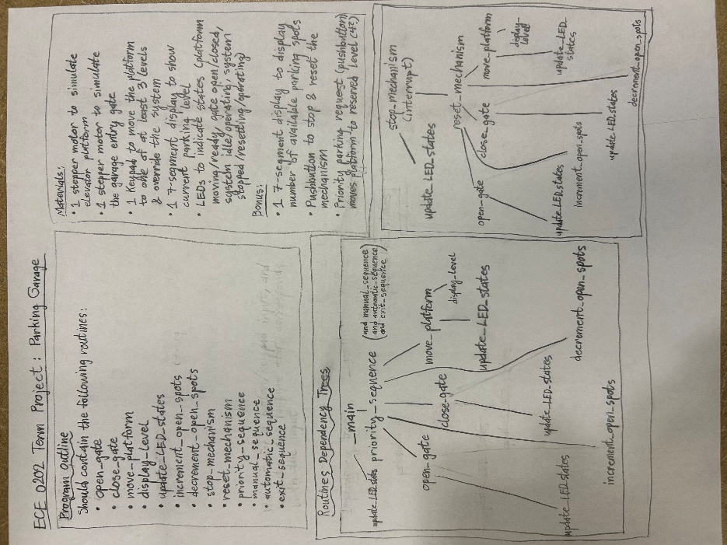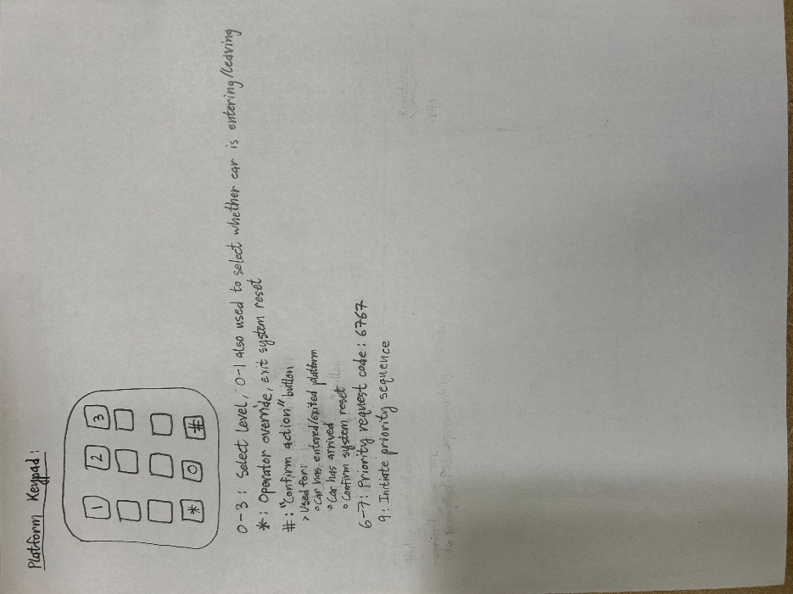

Project Specifications (from Canvas)

- The prototype must include the Nucleo-STM32L476RG microcontroller, stepper motor(s) to mimic the motion of the elevator platform and parking gate, push button(s) and/or keypad(s) for driver and operator commands, seven-segment display(s) to show the current parking level, and LEDs to indicate system status.
- The main program of the microcontroller should be primarily written in assembly language.

- One stepper motor should simulate the elevator platform that moves vehicles between parking levels.
- A second motor should simulate the garage entry gate, opening and closing when vehicles enter or exit.
- The system must support at least three parking levels (Level 1, Level 2, Level 3).
- The system should automatically assign vehicles to parking levels and move the platform accordingly.
- The operator should be able to manually override the automated system and move the platform to a specific level using push buttons or keypad input.
- The seven-segment display should indicate the current parking level or system status.
- LEDs should indicate states such as platform moving, gate open, or system idle.
- System status and events should be communicated in real time through Tera Term.
- The hardware layout and wiring should be neat and organized.
- Software should be properly annotated.

Bonus:
- Implement acceleration/deceleration of the platform using step delay or PWM.
- Display the number of available parking spots.
- Implement a priority parking request (e.g., reserved level).
- Add an emergency button for stopping and resetting the mechanism.

